**PERMISSIONS BY USER ID**

REF:

<https://stackoverflow.com/questions/38529453/how-do-i-set-permissions-for-post-requests-in-django-rest-framework>

IN ORDER TO ACHIEVE THIS GOAL, WE HAVE TO ADD SOME CONFIGURATION INSIDE THE PERMISSIONS CLASS:

1. DEFINING NEXT METHOD TO CATCH GET/ POST REQUESTS

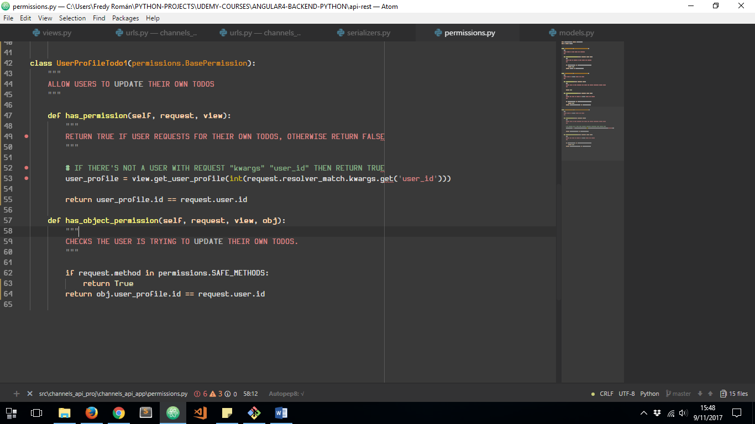

LET’S SEE IT IN ACTION:

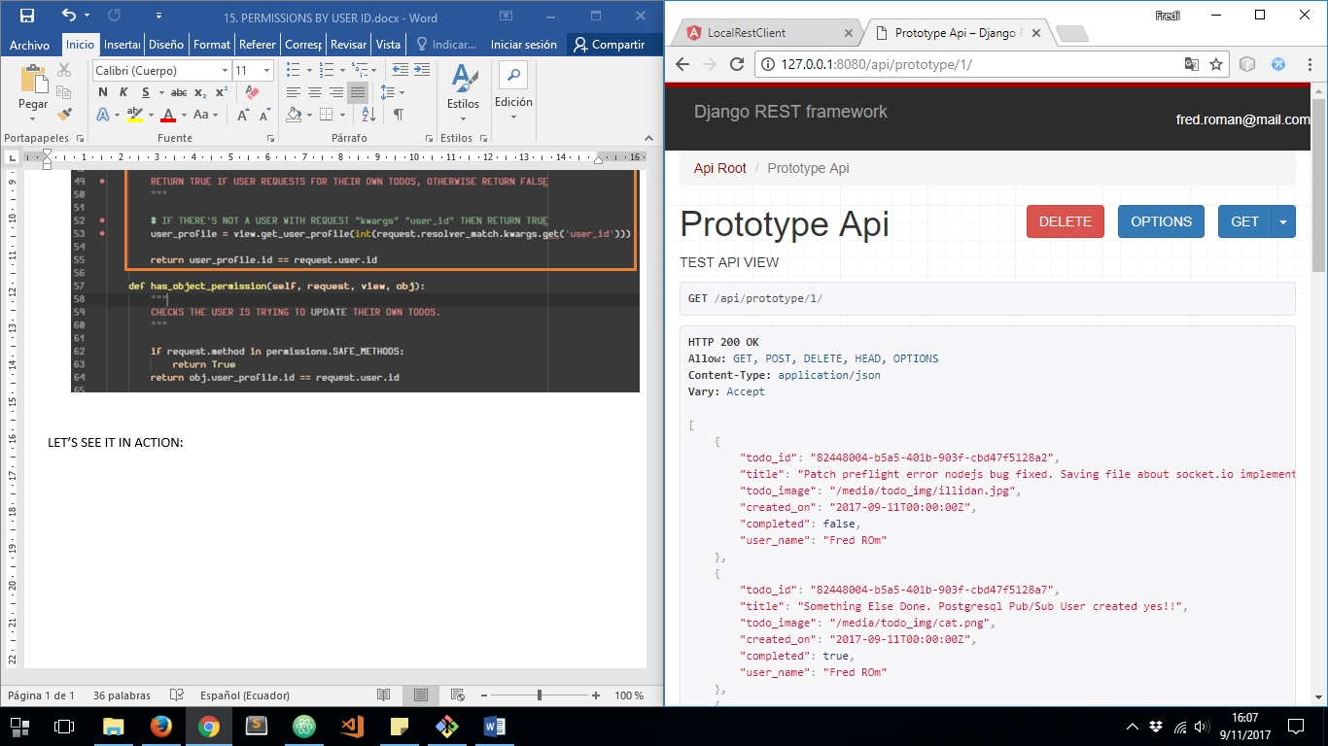

SENDING THE SAME USER ID ACCORDING TO THE LOGGED USER ID THROUGH THE URL

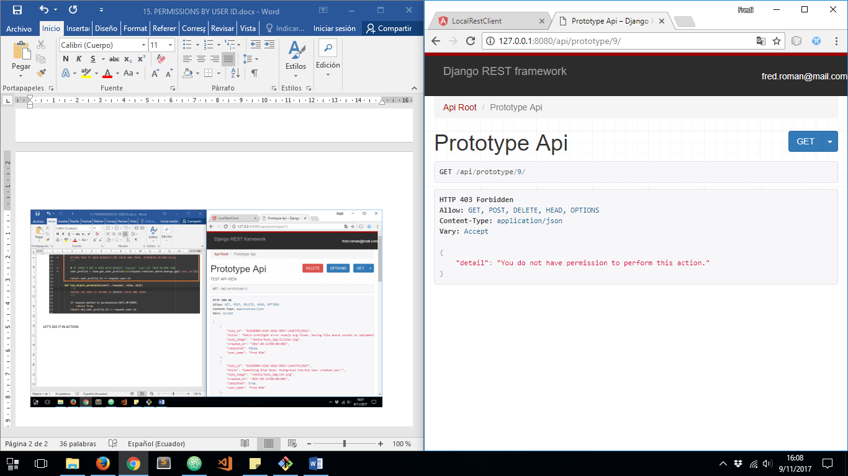

NOW SENDING AN INCORRECT USER ID ACCORDING TO THE LOGGED USER ID THROUGH THE URL